 | Short-term plan :  Unit 5: Health and body |  | School: B.Keikyev
 | Date: 24.01.2019 |  | Teacher’s name: Koishykulova Zh
 | Grade: Grade 2 A/B |  | Number present: |  |  | absent:
 | Theme of the lesson: Hats and Bats/ Parts of body
 | Learning objective(s) that this lesson is contributing to |  |  | To identify and talk about parts of the face  Begin to use with support a simple picture dictionary  respond to basic supported questions about people, objects and classroom routines  basic instructions for a limited range of classroom routines spoken slowly and distinctly
 | Lesson objectives |  |  | All learners will be able to:  - Name the vocabulary words  - Pronouns the words correctly  - Answer the questions with some support  Most learners will be able to:  - Answer the questions  - Use them in their speech  Some learners will be able to:  - Complete all worksheets correctly
 | ICT skills |  |  | Projector
 | Value links |  |  | Communication
 | Previous learning |  |  | Vocabulary of Unit 4
 | Cross curricular links |  |  | Physical Education, Anatomy
 | Intercultural awareness |  |  | Students can name body parts in different languages
 | Kazakh culture |  |  | Students can name body parts in Kazakh language
 | Pastoral Care |  |  | Assure you met all learners’ needs
 | Plan
 | Planned timings | Planned activities |  |  |  |  |  | Resources
 | Beginning  5-min  (W)  5-min | Checking of the hometask  Greeting, Objectives & Daily Question  Greet Students and tell them that they have 2 minutes to finish writing the date, topic and an answer to the question on the pictures  - After two minutes, ask a student on duty  -(Ask the daily question)  -What day is it today?  -What is the date today?  -What is the topic of the lesson?  Warm-up: Let’s play and do activities (Шаттық шеңбер)  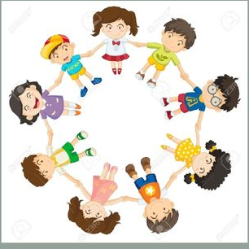  Dividing into groups:  T: I have red and green leaves. Choose one.
 | Middle  10 min  (W/I)  8min  10min | Presentation:  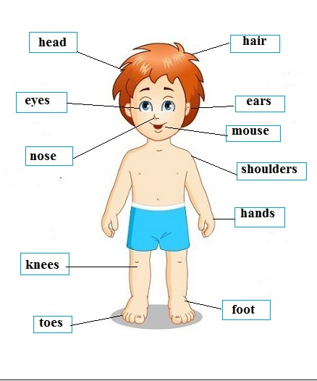  Pupils learn the words related to the theme. The teacher demonstrates pictures from the PPT and the learners pronounce after in chorus or individually. The teacher use different resources to practice new vocabulary.  HANDS  EARS  HEAD  MOUTH  HAIR  KNEES  FOOT  TOES  SHOULDER  EYES  NOSE  - Practice: Group work:  Explain the activity. Ask the students to read and complete the words looking at the pictures. Each group check their answers and give their marks .The students then read the sentences and complete the face of TEDDY BEAR .  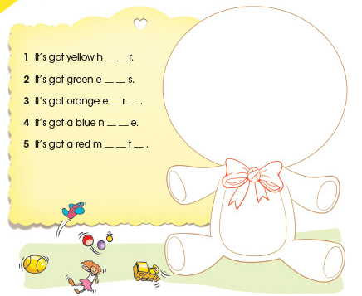  1 hear  2 eyes  3 ears  4 mouth  5 nose  Ph.Training:  Suggest students to listen to the song and revise vocabulary:  «Head, Shoulders, Knees and Toes»  Head, Shoulders, Knees and Toes  Head, Shoulders, Knees and Toes  Eyes and ears and mouth and nose  Head, Shoulders, Knees and Toes  2. Head, Shoulders, Knees and Toes  Head, Shoulders, Knees and Toes  Eyes and ears and mouth and nose  Head, Shoulders, Knees and Toes  3. Head, Shoulders, Knees and Toes  Head, Shoulders, Knees and Toes  Eyes and ears and mouth and nose  Head, Shoulders, Knees and Toes |  |  |  |  |  | Body parts  PPT  Picture dictionary  Picture  https://youtube/LXIROQNR5cM  video
 | End  2min.  (W/I) | Reflection:  Teacher give feedback to students. This might be done in oral form  Students reflect on their learning:  -What has been learned  -What remained unclear  -What it is necessary to work on |  |  |  |  |  | Worksheet 3
 | Additional information
 | Differentiation – how do you plan to give more support? How do you plan to challenge the more able learners? |  |  |  | Assessment – how are you planning to check learners’ learning? |  | Health and safety check
More able learners can be encouraged to write more for what words they learned that day at the end of the lesson. More able learners may be paired with students needing extra help for the TPS at the beginning of the lesson. |  |  |  |  | The teacher will be able to assess how well the students have acquired the new words through the Touch the Word game. The teacher will know how well the students are doing at writing the new words and sentences by circulating the room often and checking written work. |  | Lessons will be delivered in accordance with health and safety standards.
Reflection  Were the lesson  objectives/learning  objectives realistic?  Did all learners  achieve the LO?  If not, why?  Did my planned differentiation work well? Did I stick to timings? What changes did I make from my plan and why |  |  |  |  | Use the space below to reflect on your lesson. Answer the most relevant questions from the box on the left about your lesson.
Summary evaluation
What two things went really well (consider both teaching and learning)?
1:

2:

What two things would have improved the lesson (consider both teaching and learning)?
1:

2:

What have I learned from this lesson about the class orachievements/difficulties of individuals that will inform my next lesson?

